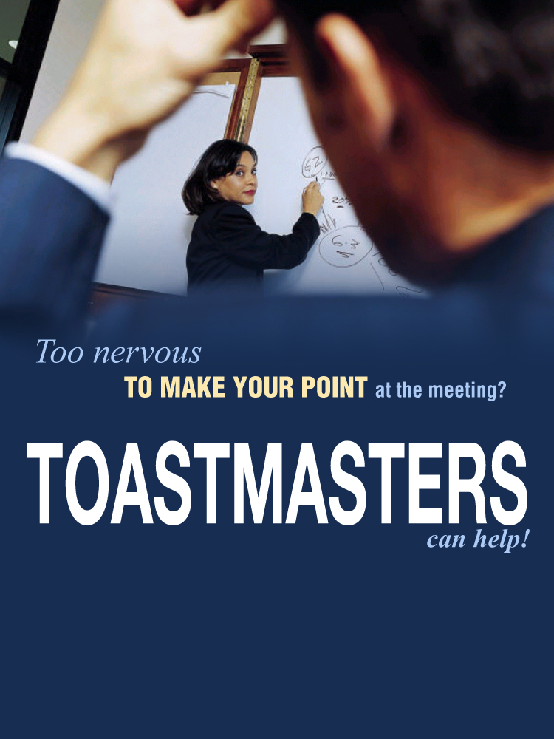

_________________________________________________________________________

ABC Toastmasters Club
Thursdays • 4:30 pm - 5:45 pm

2728 Long Street NW • Suite A

Call (505) 123-4567 or visit www.clubname.com for more information!

