Do you panic, get tongue-tied or break out in a sweat when you have to speak in front of a group of people?

If you do, Toastmasters can help.
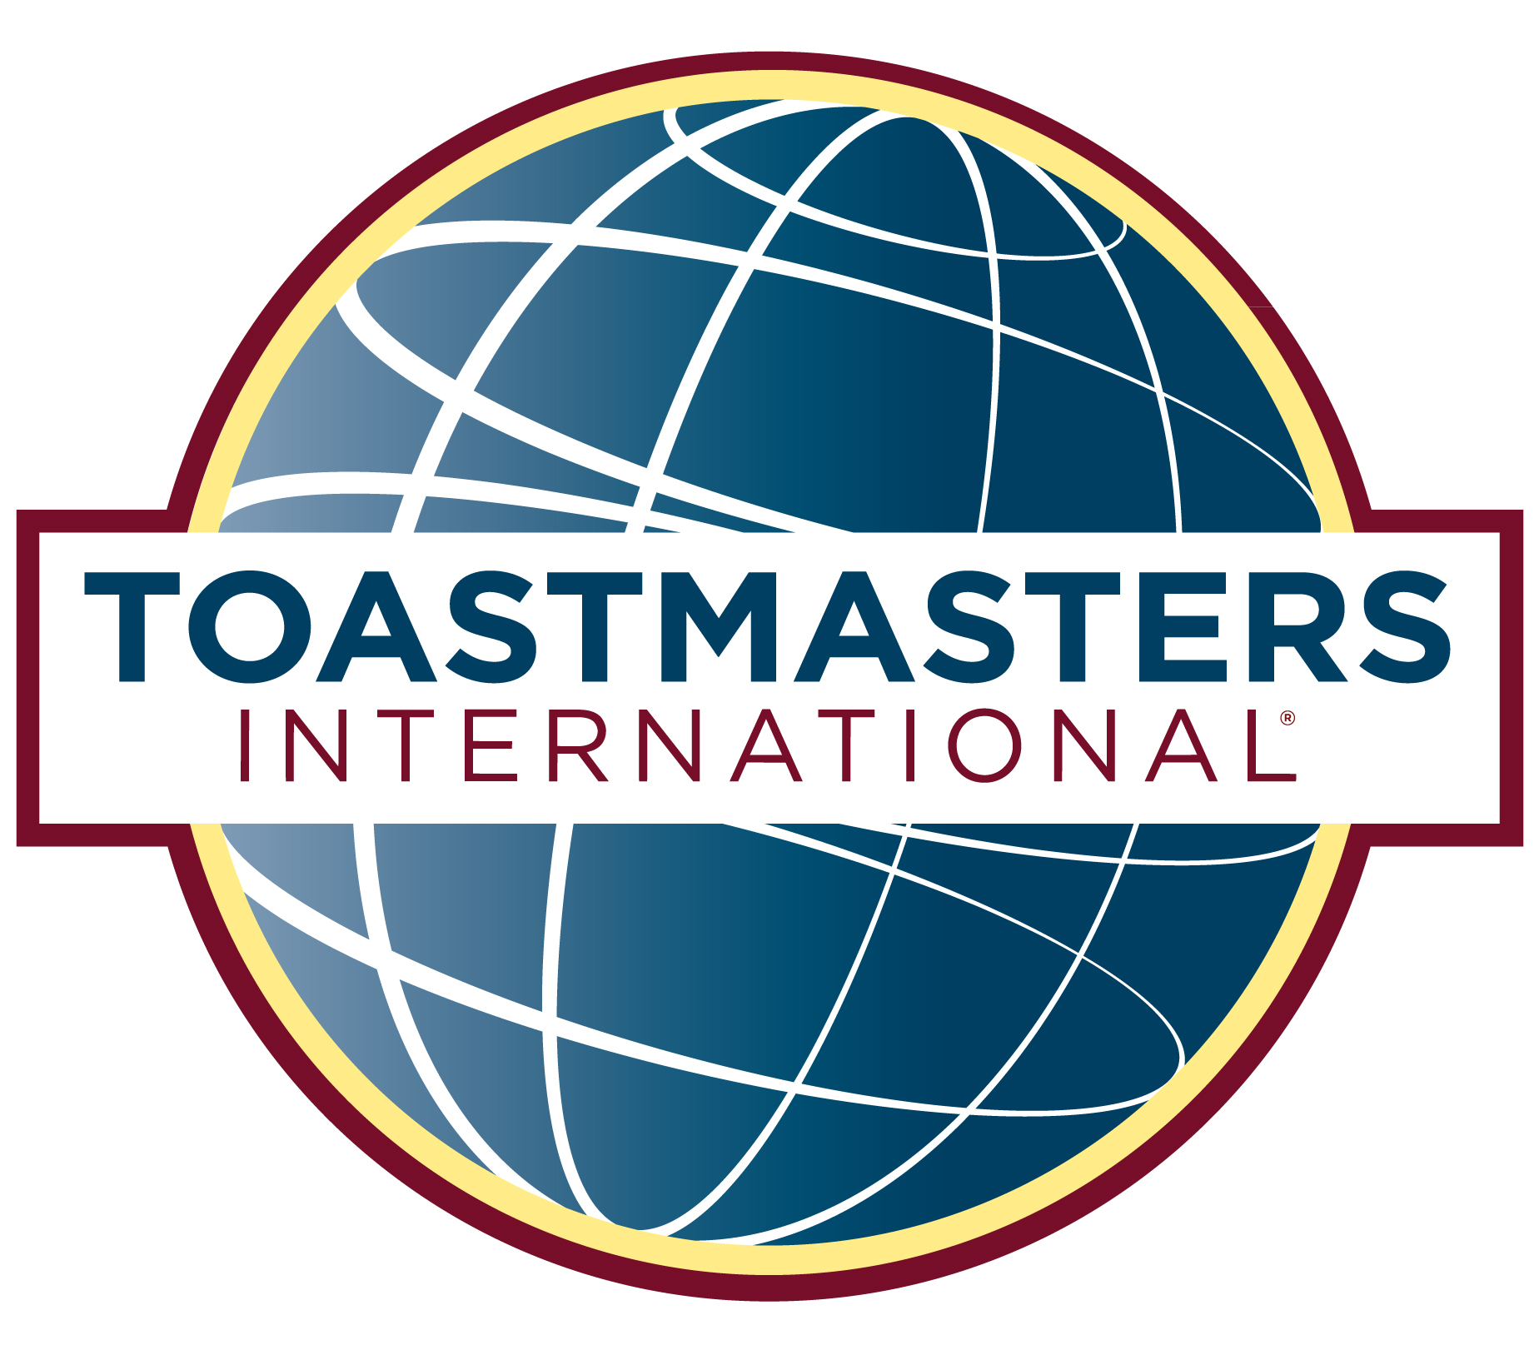
The NAME Club meets FILL IN DATE TIME AND LOCATION
Toastmasters is an organization designed to help people get over their fear of public speaking through practice in a friendly setting. It also provides leadership opportunities.

After completing the basic manual you will be more comfortable speaking in public.
For more information visit:
www.tm61.org or LOCAL WEBSITE
Guests are always welcomed. No obligation to join.

